Project – Phase two

# Objective

In the phase two you are required to improve your project further by adding features relating to Javascript, AJAX, JQuery, AngularJS. You can also use plugins related to these technologies such as Bootstrap and plug for JQuery

# Requirements

* Create a Website comprising 8 Web pages minimum
* Registration form with form validation

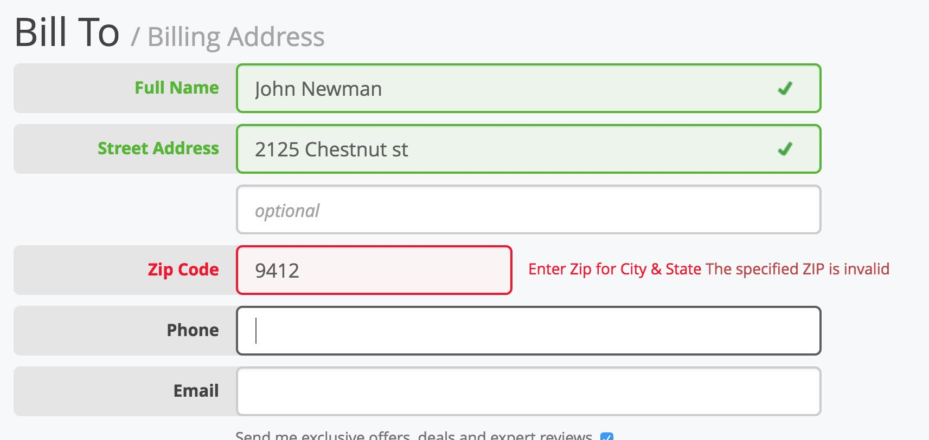

* A responsive design that should address mobile devices and desktops.
* Add AJAX for loading different sections of page

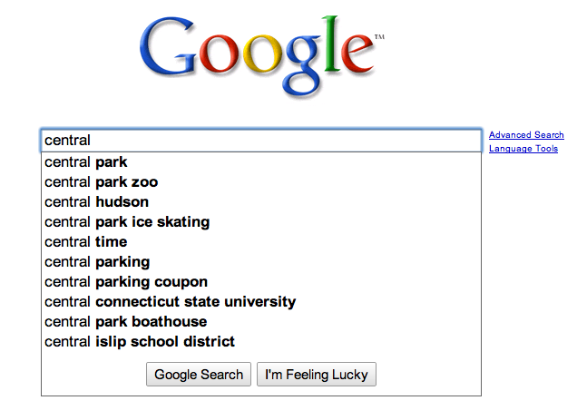

* Animations/effects

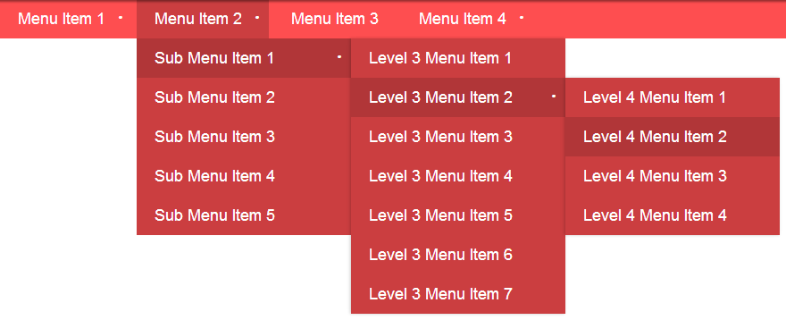

* Carousel



* API call extracting useful data relevant to Web page (some examples, you don’t have to use these only)

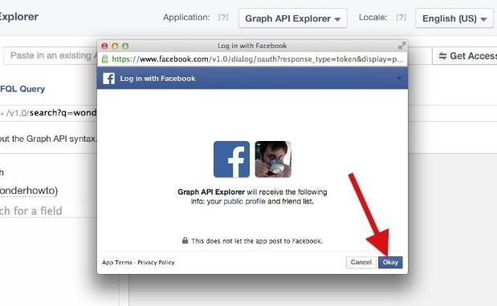 

* Dynamic Tabs



* Progress bars



* Popovers

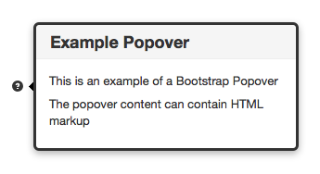

* Modal



* Tooltips

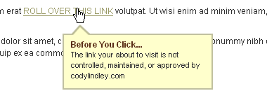

* Color Switcher



* Effect enabled navigation using Javascript/JQuery

# Grading

|  |  |  |
| --- | --- | --- |
| No. | Description | Marks |
|  | Use of APIs | 5 |
|  | Features | 10 |
|  | AJAX | 5 |
|  | Quality | 10 |
|  | **Total** | **20** |

# Negative Grading

* Work was not divided equally
* A member not understanding a code that is written in the project
* You may use external libraries like bootstrap and others. However, the project members should understand the code provided by the libraries.

# Deadline

Vivas will be conducted in the lab on Thursday 17th May 2017